Table of Contents [Credit](https://ashif.in)

1. Introduction 01
2. Objective of the Project 01
3. Project Technologies 02
4. Requirement Analysis 04
5. Hardware requirement specification:
6. Software requirement specification:
7. Software Design 05
   1. Interface Design
8. Testing 06
9. Project Module 08
10. Limitation 09
11. Scope of the project 09
12. Conclusion 09
13. Bibliography 10

**Introduction**

Quiz App is a Web based platform where students can test their knowledge about the particular modern computer technology. Student can specify the Number of questions, a wide variety of topics like Linux, DevOps, Networking, Programming (PHP, JS, Python and etc.), Cloud, Docker, Kubernetes, And lots more with their difficulty level.

This system will ask random questions based on specified criteria with a time limit to respond. After completion of Quiz student will get instant score.

Online quiz are a popular form of entertainment for web surfers. Online Quiz are generally free to play & for entertainment purposes only though ONLINE QUIZ website offer prices.

Online quiz is setup to actually test knowledge or identity a person’s attribute. Some companies use online quiz as an efficient way of testing a potential hire’s knowledge without that candidate needing to travel. [Credit](https://ashif.in)

**Objectives of the Project**

Objective of this Quiz App is students can evaluate their knowledge about modern computer technology. Quiz App System is fully developed automated system is to efficiently evaluate the candidate progress that not only save the time but also gives fast result.

**Features of Quiz App:**

* Random question will be asked each time
* Questions are based on Topic choose
* Option to change Difficulty level. *eg- Easy, Medium and Difficult*
* Time Limit for each Question to answer
* Provide instant score
* User friendly Environment

**Project Technologies**

* HTML (Hyper Text Markup Language)
* CSS (Cascading Style Sheets)
* JavaScript
* API (Application Programming Interface)

**HTML:**   
The HyperText Markup Language, or HTML is the standard markup language for documents designed to be displayed in a web browser. It can be assisted by technologies such as Cascading Style Sheets (CSS) and scripting languages such as JavaScript.

Web browsers receive HTML documents from a web server or from local storage and render the documents into multimedia web pages. HTML describes the structure of a web page semantically and originally included cues for the appearance of the document.

HTML elements are the building blocks of HTML pages. With HTML constructs, images and other objects such as interactive forms may be embedded into the rendered page. HTML provides a means to create structured documents by denoting structural semantics for text such as headings, paragraphs, lists, links, quotes and other items. HTML elements are delineated by tags, written using angle brackets. Tags such as <img /> and <input /> directly introduce content into the page. Other tags such as <p> surround and provide information about document text and may include other tags as sub-elements. Browsers do not display the HTML tags, but use them to interpret the content of the page.

**CSS:**

Cascading Style Sheets (CSS) is a style sheet language used for describing the presentation of a document written in a markup language such as HTML.[1] CSS is a cornerstone technology of the World Wide Web, alongside HTML and JavaScript.[2]

CSS is designed to enable the separation of presentation and content, including layout, colors, and fonts.[3] This separation can improve content accessibility, provide more flexibility and control in the specification of presentation characteristics, enable multiple web pages to share formatting by specifying the relevant CSS in a separate .css file which reduces complexity and repetition in the structural content as well as enabling the .css file to be cached to improve the page load speed between the pages that share the file and its formatting.

**JavaScript:**

JavaScript (/ˈdʒɑːvəˌskrɪpt/),[9] often abbreviated as JS, is a programming language that conforms to the ECMAScript specification.[10] JavaScript is high-level, often just-in-time compiled, and multi-paradigm. It has curly-bracket syntax, dynamic typing, prototype-based object-orientation, and first-class functions.

Alongside HTML and CSS, JavaScript is one of the core technologies of the World Wide Web.[11] Over 97% of websites use it client-side for web page behavior,[12] often incorporating third-party libraries.[13] Most web browsers have a dedicated JavaScript engine to execute the code on the user's device.

**API:**

An application programming interface (API) is a connection between computers or between computer programs. It is a type of software interface, offering a service to other pieces of software.[1] A document or standard that describes how to build or use such a connection or interface is called an API specification. A computer system that meets this standard is said to implement or expose an API. The term API may refer either to the specification or to the implementation.

The QuizAPI is a SaaS which lets you test your knowledge on a wide variety of technical topics. You can create your own Quiz or get random set of questions for a speicifc topic including Linux, DevOps, BASH, PHP and lots more. We offer an easy to use API which allows you to embed the quiz on your own website. [Credit](https://ashif.in)

**Requirement Analysis**

**Requirements analysis** in [systems engineering](http://en.wikipedia.org/wiki/Systems_engineering) and [software engineering](http://en.wikipedia.org/wiki/Software_engineering), encompasses those tasks that go into determining the needs or conditions to meet for a new or altered product, taking account of the possibly conflicting [requirements](http://en.wikipedia.org/wiki/Requirements) of the various [stakeholders](http://en.wikipedia.org/wiki/Stakeholder_(corporate)), such as beneficiaries or users.

Requirements analysis is critical to the success of a development project. [Requirements](http://en.wikipedia.org/wiki/Requirement) must be documented, actionable, measurable, testable, related to identified business needs or opportunities, and defined to a level of detail sufficient for system design. Requirements can be [architectural](http://en.wikipedia.org/wiki/System_architecture), [structural](http://en.wikipedia.org/wiki/Structure), [behavioral](http://en.wikipedia.org/wiki/Behavior), [functional](http://en.wikipedia.org/wiki/Functional_requirements), and [non-functional](http://en.wikipedia.org/wiki/Non-functional_requirements).

The development of project needs some requirement to make the project perform better and achieves the goal of project. In developing Online Quiz, the capabilities of computer and hardware plays a big impact on project quality. The project maker should determine the minimum requirements of hardware and also software to be used to develop a good and attractive project.

**Hardware requirement specification:**

|  |  |
| --- | --- |
| **Operating System** | Windows XP / Windows 7/ Windows 8 |
| **Hard disk** | Minimum 40 GB |
| **RAM** | Minimum 512 MB |
| **Processor** | Minimum Pentium Dual Xenon Processor |

**Software requirement specification:**

|  |
| --- |
| XAMPP Software v 3.2.1 |
| Apache server 1.8.2 |
| IDE: VS Code 1.53 |

**Software Design**

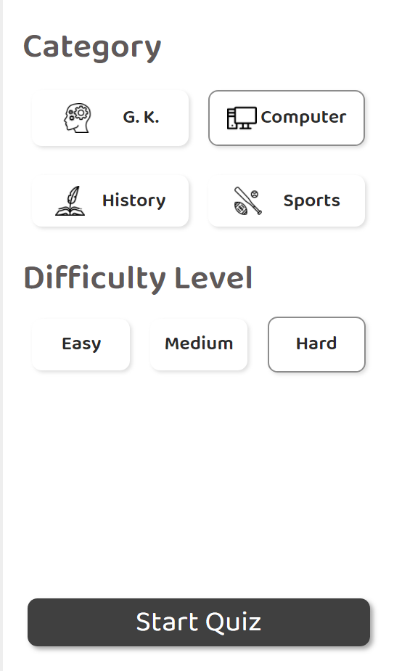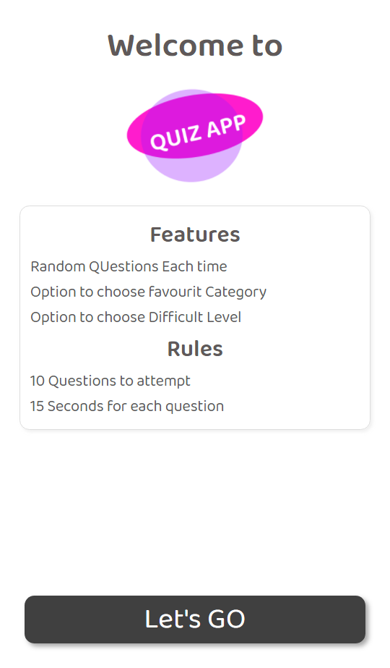

**Customize Quiz Page**

**Welcome Page**

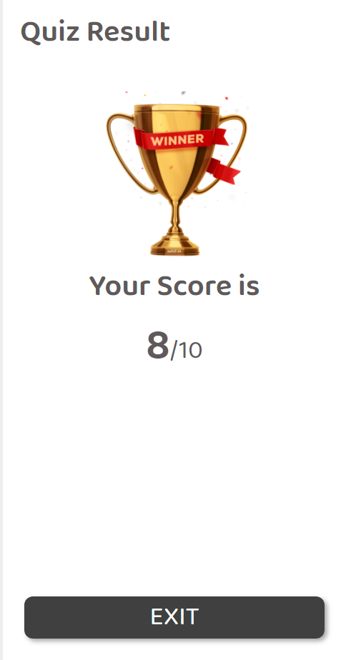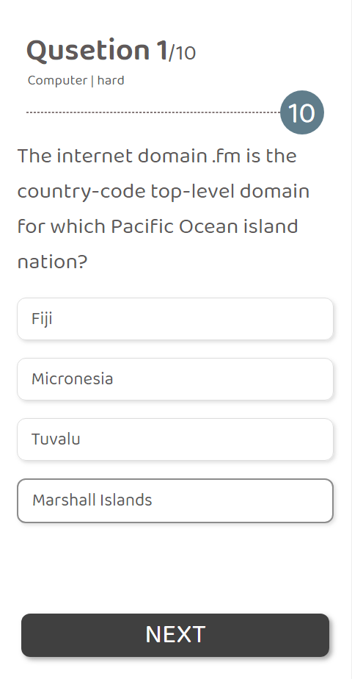

**Quiz Result Page**

**Quiz Question Page**

**Testing Technologies and Security mechanisms**

Different testing levels

* Unit testing
* Integrated testing
* Validation testing
* Output testing
* User acceptance testing

1. **Unit testing:**

Unit testing focuses on verification effort on the smallest unit of software design module. Using the unit test plans. Prepared in the design phase of the system as a guide important control paths are tested to uncover errors within the boundary of the modules. The interfaces of each of the modules under consideration are also tested. Boundary conditions were checked.

All independent paths were exercised to ensure that all statements in the module executed at least once and all error-handling paths were tested. Each unit was thoroughly tested to check if it might fall in any possible situation. This testing was carried out during the programming itself. At the end of this testing phase each unit was found to be working satisfactorily as regarded to the expected out tom the module.

1. **Integration Testing:**

Data can be across an interface one module can have an adverse effect on another's Sub function when combined may not produce the desired major function; global data structures can present problems. Integration testing is a symmetric technique for constructing tests to uncover errors associated with the interface. All modules are combined in this testing step. Then the entire program was tested as a whole.

1. **Validation Testing:**

At the culmination of integration testing software is completely assemble. As a package. Interfacing errors have been uncovered and corrected and find; series of software test-validation testing begins. Validation testing can be defined in many ways but a Simple definition is that validation succeeds when software functions in manner that is reasonably expected by the consumer.

Software validation is achieved through a series of black box tests that demonstrate conformity with requirement after validation test has been conducted one of two conditions exists.

* The function or performance Characteristics confirm to specification that are accepted.
* A validation from specification is uncovered and a deficiency created.

Deviation or errors discovered at this step in this project is corrected prior to completion of the project with the help of user by negotiating to establish a method for resolving deficiencies. Thus the proposed system under consideration has been tested by using validation testing and found to be working satisfactorily.

1. **Output testing:**

After performing the validation testing the next step is output testing of the proposed system since a system is useful if it does not produce the required output in the specific format required by them tests the output generator displayed on the system under consideration. Here the output is considered in two ways - one is onscreen and the other is printed format. The output formation the screen is found to be correct as the format was designed in the system design phase according to the user needs. As far as hardcopies are considered it goes in terms with the user requirement Hence output testing does not result any correction in the system.

1. **User acceptance Testing:**

User acceptance of the system is a key factor for success of any system. The system under consideration is tested for user acceptance by constantly keeping in touch with prospective System and user at the time of developing and making changes whenever required. [Credit](https://ashif.in)

**Project modules**

1. **Instruction Module**

This is the first Module in this Quiz Website. It is the welcome page which contain Quiz logo, and all the required information about the Quiz including Time Duration, Question Categories and option to Choose difficulty level etc.

When user will read all the information, he can proceed to the quiz by clicking on “Lets’s GO” button at the bottom.

1. **Quiz Module**

This module will show questions to the user one by one and student has to choose the correct option among 4 options. Time limit to choose the option in 30 Seconds, Student has to choose their option in the given time limit, otherwise options will be got locked, he/she can’t choose.

Also, if one option is selected by the student, option will be locked, he/she can’t change them.

To view next question, he/she has to click on “NEXT” button.

1. **Status view module**

This module has status of quiz including Time left, No of Question asked, Number of questions left etc.

1. **Result Module**

This is the last module, It contains the total score of the student based on the option selected. [Credit](https://ashif.in)

**Limitations**

* It cannot be used as offline since it is online program.
* Internet connection is required.
* Basic computer knowledge is required to work on the system.

**Future scope and further enhancement of the project**

* In future we can make android mobile based application.
* In future we can add features like web-cam based verification system, Certification verification, Interview process through online, Identity card after approval, etc.

**Conclusion**

This website stores admission details submitted by students and college staff. This project will eliminate all the manual intervention and increase the speed of whole process. The system works in Apache server which executes PHP script and MySQL as backend for the database. The system is strong to handle daily operations where the database is cleared over certain time. [Credit](https://ashif.in)

**Bibliography**

Website: [www.w3schools.com](http://www.w3schools.com)

Website: https://quizapi.io

Website:

<https://stackoverflow.com>